Análisis de Factores. Resumen.

- El Análisis de Factores servirá para agrupar nuestras variables.
- Se tiene que relacionar la variables originales por medio de unas “nuevas” que denominaremos Factores, si, las originales en término de una “nuevas”, los factores
- Los coeficiente de los factores nos indicarán la asociación en la las variables originales y los factores, esto se debe a que la covarianza entre las variables originales y los factores es A
- La variabilidad del modelo original se divide en la comunalidad y la unicidad
- Existen diversos métodos para la estimación de los coeficientes de los Factores
- Al modelo que se obtiene se le pueden aplicar transformaciones que logran identificar y expresar más claramente la relación entre las variables originales y los Factores, podemos mencionar dos grandes grupos de dichas transformaciones Oblicuas y Ortogonales.
- Después de realizar las transformaciones, tenemos que buscar con cuántos factores utilizar, algunas formas de identificación serían:
- Aplicando componentes principales antes y en base al número de componentes que decidamos quedar quedarnos con un número similar de factores.
- Por experiencia y/o conocimiento del problema, el conocimiento del problema es ver la correlación entre las variables, seguramente se agruparan las variables con mayor correlación.
- Ver el peso de los factores, aquí pueden existir variables que están presentes en todos los factores o bien variables que se representan con un solo factor, según la aplicación y circunstancias de su problema.
- A cada grupo de variables asociadas al factor es importante identificarla con algún nombre dado por medio de la característica que representan.
- Si están interesados en saber qué influencia hay para cada uno de los “individuos” originales con los Factores encontrados (o nuevos “individuos”), se tiene que estimar los Factores por medio de las variables originales, un método para hacerlo es por medio de la Regresión Lineal
- AL obtener la relación anterior y aplicar la transformación en nuestros datos originales sabremos el “valor “ que cada “individuo” tiene con cada factor, en cada factor podemos determinar la afectación o influencia del “individuo” con dicho Factor.

DOS EJEMPLOS DE ANALISIS DE FACTORES

- Este es un ejemplo construido.

Se miden seis características a n=18 sujetos, pero en realidad… v2 es una variación de v1 , la v4 de v3 y v6 de v5. Es decir, en realidad hay solo tres (esperamos tener 3 factores)

v1 <- c(1,1,1,1,1,1,1,1,1,1,3,3,3,3,3,4,5,6)
v2 <- c(1,2,1,1,1,1,2,1,2,1,3,4,3,3,3,4,6,5)
v3 <- c(3,3,3,3,3,1,1,1,1,1,1,1,1,1,1,5,4,6)
v4 <- c(3,3,4,3,3,1,1,2,1,1,1,1,2,1,1,5,6,4)
v5 <- c(1,1,1,1,1,3,3,3,3,3,1,1,1,1,1,6,4,5)
v6 <- c(1,1,1,2,1,3,3,3,4,3,1,1,1,2,1,6,5,4)
m1 <- cbind(v1,v2,v3,v4,v5,v6)
#Así queda nuestra base
m1

par(mfrow=c(2,2))
matplot(m1[,1:2],col=c(1,1),type="b")
matplot(m1[,3:4],col=c(2,2),type="b")
matplot(m1[,5:6],col=c(3,3),type="b")
matplot(m1,type="b",col=c(1,1,2,2,3,3))
par(mfrow=c(1,1))

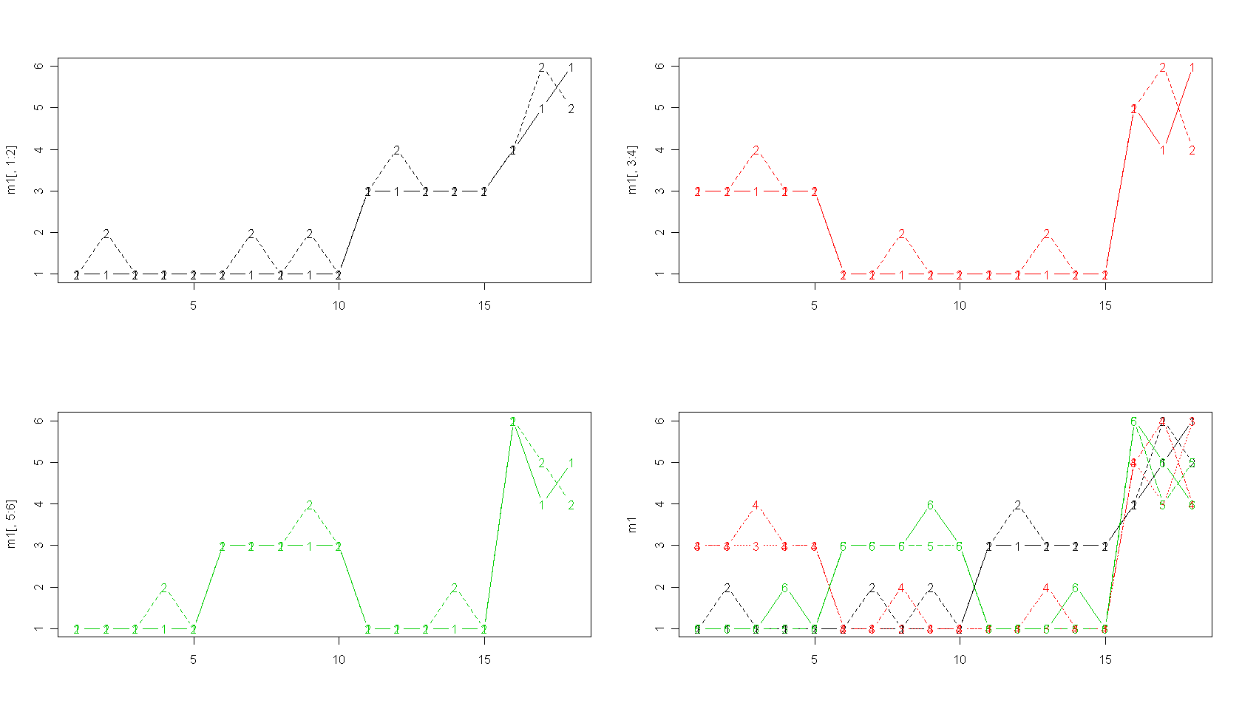
cor(m1)
Correlaciones altas

v1 v2 v3 v4 v5 v6
v1 1.0000000 0.9393083 0.5128866 0.4320310 0.4664948 0.4086076
v2 0.9393083 1.0000000 0.4124441 0.4084281 0.4363925 0.4326113
v3 0.5128866 0.4124441 1.0000000 0.8770750 0.5128866 0.4320310
v4 0.4320310 0.4084281 0.8770750 1.0000000 0.4320310 0.4323259
v5 0.4664948 0.4363925 0.5128866 0.4320310 1.0000000 0.9473451
v6 0.4086076 0.4326113 0.4320310 0.4323259 0.9473451 1.0000000

# Requerimos la librería psych
# la rotacion puede ser "none", "varimax", "quatimax", "promax", "oblimin", "simplimax", or "cluster"

library(psych)
fa(m1,nfactors=3,fm="pa",rotate="none",max.iter=100)

Factor Analysis using method = pa
Call: fa(r = m1, nfactors = 3, rotate = "none", max.iter = 100, fm = "pa")
Standardized loadings (pattern matrix) based upon correlation matrix
PA1 PA2 PA3 h2 u2 com
Unicidad
v1 0.80 0.53 -0.20 0.95 0.046 1.9
v2 0.77 0.52 -0.27 0.93 0.069 2.0
v3 0.78 -0.04 0.55 0.92 0.083 1.8
v4 0.73 -0.04 0.55 0.84 0.161 1.9
Comunalidad
v5 0.81 -0.47 -0.28 0.95 0.048 1.9
v6 0.78 -0.49 -0.31 0.95 0.055 2.1

PA1 PA2 PA3
SS loadings 3.62 1.02 0.90
Proportion Var 0.60 0.17 0.15
Cumulative Var 0.60 0.77 0.92
Proportion Explained 0.65 0.18 0.16
Cumulative Proportion 0.65 0.84 1.00

Mean item complexity = 1.9
Test of the hypothesis that 3 factors are sufficient.

The degrees of freedom for the null model are 15 and the objective function was 7.21 with Chi Square of 102.2
The degrees of freedom for the model are 0 and the objective function was 0.62

The root mean square of the residuals (RMSR) is 0.02
The df corrected root mean square of the residuals is NA

The harmonic number of observations is 18 with the empirical chi square 0.13 with prob < NA
The total number of observations was 18 with MLE Chi Square = 7.52 with prob < NA

Tucker Lewis Index of factoring reliability = -Inf
Fit based upon off diagonal values = 1
Measures of factor score adequacy
PA1 PA2 PA3
Correlation of scores with factors 0.99 0.97 0.95
Multiple R square of scores with factors 0.98 0.95 0.91
Minimum correlation of possible factor scores 0.96 0.90 0.82

# Con Varimax

fa(m1,nfactors=3,fm="pa",rotate="varimax")

Factor Analysis using method = pa
Call: fa(r = m1, nfactors = 3, rotate = "varimax", fm = "pa")
Standardized loadings (pattern matrix) based upon correlation matrix
PA1 PA2 PA3 h2 u2 com
v1 0.20 0.92 0.26 0.95 0.046 1.3
v2 0.22 0.92 0.18 0.93 0.069 1.2
Vemos como con la rotación se nota mejor la relación existente
v3 0.24 0.23 0.90 0.92 0.083 1.3
v4 0.21 0.20 0.87 0.84 0.161 1.2
v5 0.92 0.22 0.25 0.95 0.048 1.3
v6 0.93 0.20 0.21 0.95 0.055 1.2

PA1 PA2 PA3
SS loadings 1.89 1.88 1.77
Proportion Var 0.31 0.31 0.30
Cumulative Var 0.31 0.63 0.92
Proportion Explained 0.34 0.34 0.32
Cumulative Proportion 0.34 0.68 1.00

Mean item complexity = 1.2
Test of the hypothesis that 3 factors are sufficient.

The degrees of freedom for the null model are 15 and the objective function was 7.21 with Chi Square of 102.2
The degrees of freedom for the model are 0 and the objective function was 0.62

The root mean square of the residuals (RMSR) is 0.02
The df corrected root mean square of the residuals is NA

The harmonic number of observations is 18 with the empirical chi square 0.13 with prob < NA
The total number of observations was 18 with MLE Chi Square = 7.52 with prob < NA

Tucker Lewis Index of factoring reliability = -Inf
Fit based upon off diagonal values = 1
Measures of factor score adequacy
PA1 PA2 PA3
Correlation of scores with factors 0.98 0.98 0.96
Multiple R square of scores with factors 0.96 0.96 0.92
Minimum correlation of possible factor scores 0.92 0.92 0.84

# con rotación Promax

fa(m1,nfactors=3,fm="pa",rotate="promax")

Factor Analysis using method = pa
Call: fa(r = m1, nfactors = 3, rotate = "promax", fm = "pa")
Standardized loadings (pattern matrix) based upon correlation matrix
PA1 PA2 PA3 h2 u2 com
v1 -0.02 0.96 0.05 0.95 0.046 1
v2 0.02 0.97 -0.04 0.93 0.069 1
v3 0.01 0.02 0.94 0.92 0.083 1
v4 -0.01 -0.01 0.92 0.84 0.161 1
v5 0.95 0.01 0.03 0.95 0.048 1
v6 0.99 -0.01 -0.02 0.95 0.055 1

PA1 PA2 PA3
SS loadings 1.89 1.88 1.76
Proportion Var 0.32 0.31 0.29
Cumulative Var 0.32 0.63 0.92
Proportion Explained 0.34 0.34 0.32
Cumulative Proportion 0.34 0.68 1.00

With factor correlations of
PA1 PA2 PA3
PA1 1.00 0.45 0.49
PA2 0.45 1.00 0.48
PA3 0.49 0.48 1.00

Mean item complexity = 1
Test of the hypothesis that 3 factors are sufficient.

The degrees of freedom for the null model are 15 and the objective function was 7.21 with Chi Square of 102.2
The degrees of freedom for the model are 0 and the objective function was 0.62

The root mean square of the residuals (RMSR) is 0.02
The df corrected root mean square of the residuals is NA

The harmonic number of observations is 18 with the empirical chi square 0.13 with prob < NA
The total number of observations was 18 with MLE Chi Square = 7.52 with prob < NA

Tucker Lewis Index of factoring reliability = -Inf
Fit based upon off diagonal values = 1
Measures of factor score adequacy
PA1 PA2 PA3
Correlation of scores with factors 0.99 0.99 0.97
Multiple R square of scores with factors 0.97 0.97 0.94
Minimum correlation of possible factor scores 0.95 0.94 0.89

# Para ver solo las “cargas de cada factor

fa(m1,nfactors=3,fm="pa",rotate="promax")$load

Loadings:
PA1 PA2 PA3
v1 0.958
v2 0.975
v3 0.944
v4 0.923
v5 0.954
v6 0.985

PA1 PA2 PA3
SS loadings 1.881 1.869 1.749
Proportion Var 0.314 0.311 0.292
Cumulative Var 0.314 0.625 0.916

# grafiquemos el peso de los dos primeros factores

x<-fa(m1,nfactors=3,fm="pa",rotate="promax")
x

plot(x$load[,1:2], col="white")
text(x$load[,1:2], labels = row.names(x$loadings[,1:2]))

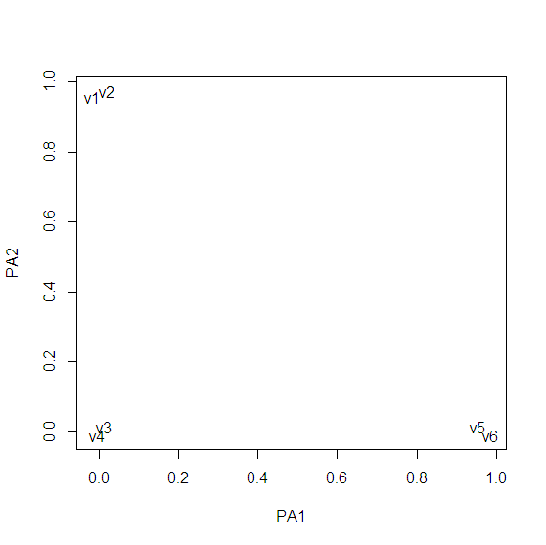

# Utilizando máxima verosimilitud aún sabiendo el problema de normalidad y con rotación Promax

fa(m1,nfactors=3,fm="ml",rotate="promax")

Factor Analysis using method = ml
Call: fa(r = m1, nfactors = 3, rotate = "promax", fm = "ml")

Warning: A Heywood case was detected.
Standardized loadings (pattern matrix) based upon correlation matrix
ML2 ML1 ML3 h2 u2 com
v1 -0.05 0.98 0.07 1.00 0.005 1
v2 0.05 0.95 -0.06 0.90 0.101 1
v3 -0.04 0.03 1.00 1.00 0.005 1
v4 0.04 -0.02 0.87 0.78 0.224 1
v5 0.91 0.03 0.06 0.92 0.084 1
v6 1.03 -0.02 -0.05 1.00 0.005 1

ML2 ML1 ML3
SS loadings 1.90 1.89 1.78
Proportion Var 0.32 0.31 0.30
Cumulative Var 0.32 0.63 0.93
Proportion Explained 0.34 0.34 0.32
Cumulative Proportion 0.34 0.68 1.00

With factor correlations of
ML2 ML1 ML3
ML2 1.00 0.46 0.50
ML1 0.46 1.00 0.46
ML3 0.50 0.46 1.00

Mean item complexity = 1
Test of the hypothesis that 3 factors are sufficient.

The degrees of freedom for the null model are 15 and the objective function was 7.21 with Chi Square of 102.2
The degrees of freedom for the model are 0 and the objective function was 0.48

The root mean square of the residuals (RMSR) is 0.02
The df corrected root mean square of the residuals is NA

The harmonic number of observations is 18 with the empirical chi square 0.3 with prob < NA
The total number of observations was 18 with MLE Chi Square = 5.78 with prob < NA

Tucker Lewis Index of factoring reliability = -Inf
Fit based upon off diagonal values = 1
Measures of factor score adequacy
ML2 ML1 ML3
Correlation of scores with factors 1.00 1.00 1.00
Multiple R square of scores with factors 1.00 1.00 1.00
Minimum correlation of possible factor scores 0.99 0.99 0.99
Warning message:
In fac(r = r, nfactors = nfactors, n.obs = n.obs, rotate = rotate, :
A Heywood case was detected. Examine the loadings carefully.

# Scores utilizando regresión y con rotación Promax

fa(m1,nfactors=3,fm="pa",rotate="promax",scores="regression")$scores

PA1 PA2 PA3
[1,] -0.8221103 -0.8469670 0.4058514
[2,] -0.8077347 -0.6060231 0.4356354
[3,] -0.8137591 -0.8317576 0.5870353
Estos serían los valores que toma cada factor en los 18 sujetos. Usando el método de Regresión para estimarlos.
[4,] -0.5327573 -0.8214603 0.4740838
[5,] -0.8221103 -0.8469670 0.4058514
[6,] 0.4237658 -0.8264945 -0.8165441
[7,] 0.4381414 -0.5855507 -0.7867601
[8,] 0.4321170 -0.8112851 -0.6353602
[9,] 0.7274945 -0.5600440 -0.7185277
[10,] 0.4237658 -0.8264945 -0.8165441
[11,] -0.8205140 0.4236120 -0.8108130
[12,] -0.8061384 0.6645559 -0.7810291
[13,] -0.8121628 0.4388215 -0.6296291
[14,] -0.5311609 0.4491187 -0.7425807
[15,] -0.8205140 0.4236120 -0.8108130
[16,] 2.3366989 1.0960546 1.7438491
[17,] 1.4037071 2.0105467 1.5745000
[18,] 1.4032710 2.0567225 1.9217949
>

# Scores utilizando Bartlett y con rotación Promax

fa(m1,nfactors=3,fm="pa",rotate="promax",scores="Bartlett")$scores

PA1 PA2 PA3
[1,] -1.0889054 -1.1202171 1.5256750
Estos serían los valores que toma cada factor en los 18 sujetos. Usando el método de Bartlett para estimarlos.
[2,] -1.2303983 -0.5804138 1.3236186
[3,] -1.3064894 -1.3278012 2.1565224
[4,] -0.5613891 -1.2747230 1.3360233
[5,] -1.0889054 -1.1202171 1.5256750
[6,] 1.4544203 -1.0213164 -1.1146439
[7,] 1.3129275 -0.4815131 -1.3167004
[8,] 1.2368364 -1.2289006 -0.4837965
[9,] 1.8404438 -0.6360191 -1.5063521
[10,] 1.4544203 -1.0213164 -1.1146439
[11,] -0.9540462 1.3919272 -1.0948580
[12,] -1.0955390 1.9317305 -1.2969145
[13,] -1.1716302 1.1843430 -0.4640106
[14,] -0.4265299 1.2374213 -1.2845098
[15,] -0.9540462 1.3919272 -1.0948580

2. Ejemplo con datos de habilidad.

The tests are described as
general:
a non-verbal measure of general intelligence using Cattell's culture-fair test.
picture:
a picture-completion test
blocks:
block design
maze:
mazes
reading:
reading comprehension
vocab:
vocabulary

# ya viene precargada

ability.cov

$cov
general picture blocks maze reading vocab
general 24.641 5.991 33.520 6.023 20.755 29.701
picture 5.991 6.700 18.137 1.782 4.936 7.204
blocks 33.520 18.137 149.831 19.424 31.430 50.753
maze 6.023 1.782 19.424 12.711 4.757 9.075
reading 20.755 4.936 31.430 4.757 52.604 66.762
vocab 29.701 7.204 50.753 9.075 66.762 135.292

$center
[1] 0 0 0 0 0 0

$n.obs
[1] 112

habilidad<-ability.cov$cov
habilidad

general picture blocks maze reading vocab
general 24.641 5.991 33.520 6.023 20.755 29.701
picture 5.991 6.700 18.137 1.782 4.936 7.204
blocks 33.520 18.137 149.831 19.424 31.430 50.753
maze 6.023 1.782 19.424 12.711 4.757 9.075
reading 20.755 4.936 31.430 4.757 52.604 66.762
vocab 29.701 7.204 50.753 9.075 66.762 135.292

# Revisemos el mismo ejemplo pero con otra función

example(ability.cov)

ablty.> require(stats)
[1] TRUE
ablty.> (ability.FA <- factanal(factors = 1, covmat=ability.cov))
Call:
factanal(factors = 1, covmat = ability.cov)

Uniquenesses:
general picture blocks maze reading vocab
0.535 0.853 0.748 0.910 0.232 0.280
Loadings:
Factor1
general 0.682
picture 0.384
blocks 0.502
maze 0.300
reading 0.877
vocab 0.849
Factor1
SS loadings 2.443
Proportion Var 0.407

Test of the hypothesis that 1 factor is sufficient.
The chi square statistic is 75.18 on 9 degrees of freedom.
The p-value is 1.46e-12

ablty.> update(ability.FA, factors=2)
Call:
factanal(factors = 2, covmat = ability.cov)

Uniquenesses:
general picture blocks maze reading vocab
0.455 0.589 0.218 0.769 0.052 0.334

Loadings:
Factor1 Factor2
general 0.499 0.543
picture 0.156 0.622
blocks 0.206 0.860
maze 0.109 0.468
reading 0.956 0.182
vocab 0.785 0.225

Factor1 Factor2
SS loadings 1.858 1.724
Proportion Var 0.310 0.287
Cumulative Var 0.310 0.597

Test of the hypothesis that 2 factors are sufficient.
The chi square statistic is 6.11 on 4 degrees of freedom.
The p-value is 0.191

ablty.> update(ability.FA, factors=2, rotation="promax")

Call:
factanal(factors = 2, covmat = ability.cov, rotation = "promax")

Uniquenesses:
general picture blocks maze reading vocab
0.455 0.589 0.218 0.769 0.052 0.334

Loadings:
Factor1 Factor2
general 0.364 0.470
picture 0.671
blocks 0.932
maze 0.508
reading 1.023
vocab 0.811

Factor1 Factor2
SS loadings 1.853 1.807
Proportion Var 0.309 0.301
Cumulative Var 0.309 0.610

Test of the hypothesis that 2 factors are sufficient.
The chi square statistic is 6.11 on 4 degrees of freedom.
The p-value is 0.191

